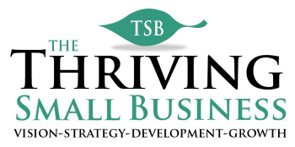

Employee Goal Example
Goal (what) | Tactical Steps (how) | Responsible  Person (who) | Measured by | Due Date (when) | Status
Improve employee satisfaction by 10 (72-82) pts by end of 4th quarter 20XX. | Hold employee focus group | Betty Smith | Scheduled date | February 15 | Completed
 | Identify employee issues | Betty Smith | Focus group feedback | March 15 | Completed
 | Develop action plan to address issues. | Betty Smith | Final action plan | April 1 | In Process
 | Implement action plan. | Betty Smith  Tom Jackson | Schedule completion date | June 30 | Not started
 | Resurvey employees to assess effectiveness of action plan. | Betty Smith  Tom Jackson | Score of 82 - Increase of 10 pts. | January 1 | Not started

