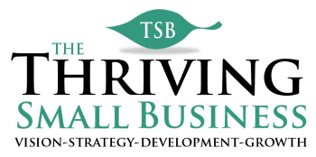

Example Employee Goal:

Example Employee Goal
Objective(goal) | Action Steps | Responsible Person | Measured by: | Due Date | Status
1. Facilitate employee focus group. | Identify employees representing each department. | Susan Jones  Department managers. | Due Date | April 15 | Completed
 | Identify date, time and location. | Susan Jones | Due Date | April 30 | Completed
 | Send invitations to employees and copy managers. | Susan Jones | Due Date | May 15 | Completed
 | Review satisfaction scores and develop discussion points. | Susan Jones | Due Date | May 30 | Completed
 | Prepare room for focus group. | Susan Jones | Due Date | June 15 | In Process
 | Facilitate focus group. | Susan Jones | Due Date | June 30 | In Process

Note: This document is meant to serve as an example form and should not be construed as a legal document. Please contact a legal professional for legal language for your specific organization.

