ABC Printing Company
Example Paid Time-off Request Form
Employee Name: | Date:
Department:
□ Birthday Holiday  □ PTO - □ Planned □ Unplanned | □ Bereavement  □ EIB (extended Illness Bank)
Dates Requested: From: _______ To: _______  Return Date: ___________________________ | # of Days: ______________________  # of Hours: ______________________
Employee Signature: ______________________  Supervisor Signature: ______________________ | Date: ______________________  Date: ______________________
HR Use Only:  PTO Hours Accrued: _______________________  PTO Hours Used: __________________________  PTO Hours Available: ______________________  HR Approval: _____________________________ | Date: ______________________
To keep track of hours used, create an excel spreadsheet that calculates as hours are added or subtracted from the bank. Keep one tab for each employee and a new file for each calendar year.

For example: Sue Smith 20xx PTO Report

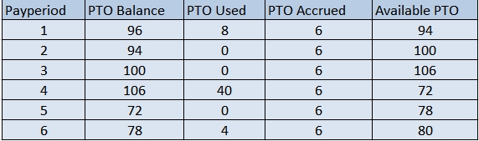

Setting up a system is key to tracking employee PTO usage.

